Name : Arshiya Tabassum A

Superset ID : 6424209

WEEK 4

**Hands on 1**

**Create a Spring Web Project using Maven**

Code:

package com.cognizant.springlearn;

import org.slf4j.Logger;

import org.slf4j.LoggerFactory;

import org.springframework.boot.SpringApplication;

import org.springframework.boot.autoconfigure.SpringBootApplication;

*@SpringBootApplication*

public class SpringLearnApplication {

private static final Logger ***LOGGER*** = LoggerFactory.*getLogger*(SpringLearnApplication.class);

public static void main(String[] args) {

***LOGGER***.info("START");

SpringApplication.*run*(SpringLearnApplication.class, args);

***LOGGER***.info("END");

}

}

Output:

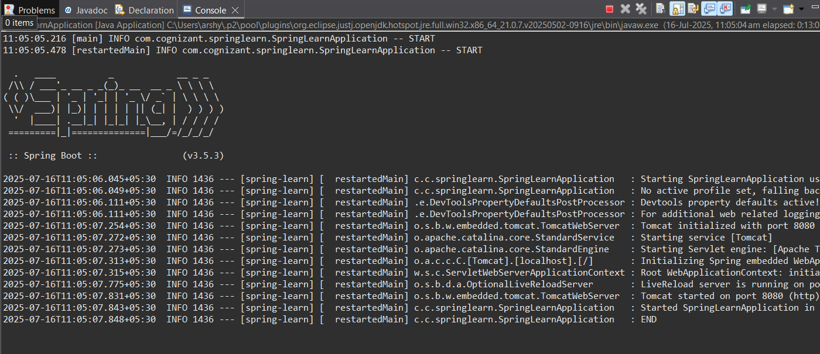

**Hands on 2**

**Spring Core – Load SimpleDateFormat from Spring Configuration XML**

Code :

**SpringLearnApplication.java**

package com.cognizant.springlearn;

import org.slf4j.Logger;

import org.slf4j.LoggerFactory;

import org.springframework.boot.SpringApplication;

import org.springframework.boot.autoconfigure.SpringBootApplication;

import org.springframework.context.ApplicationContext;

import org.springframework.context.support.ClassPathXmlApplicationContext;

import java.text.SimpleDateFormat;

import java.util.Date;

*@SpringBootApplication*

public class SpringLearnApplication {

private static final Logger ***LOGGER*** = LoggerFactory.*getLogger*(SpringLearnApplication.class);

public static void main(String[] args) {

***LOGGER***.info("Application START");

SpringApplication.*run*(SpringLearnApplication.class, args);

SpringLearnApplication app = new SpringLearnApplication();

app.displayDate();

***LOGGER***.info("Application END");

}

public void displayDate() {

***LOGGER***.info("displayDate START");

try (ClassPathXmlApplicationContext context = new ClassPathXmlApplicationContext("date-format.xml")) {

SimpleDateFormat format = context.getBean("dateFormat", SimpleDateFormat.class);

Date date = format.parse("31/12/2018");

***LOGGER***.debug("Parsed Date: {}", date);

} catch (Exception e) {

***LOGGER***.error("Date parsing error", e);

}

***LOGGER***.info("displayDate END");

}

}

**date-format.xml**

<?xml version="1.0" encoding="UTF-8"?>

<beans xmlns="http://www.springframework.org/schema/beans"

xmlns:xsi="http://www.w3.org/2001/XMLSchema-instance"

xsi:schemaLocation="

http://www.springframework.org/schema/beans

http://www.springframework.org/schema/beans/spring-beans.xsd">

<bean id="dateFormat" class="java.text.SimpleDateFormat">

<constructor-arg value="dd/MM/yyyy"/>

</bean>

</beans>

**Output :**

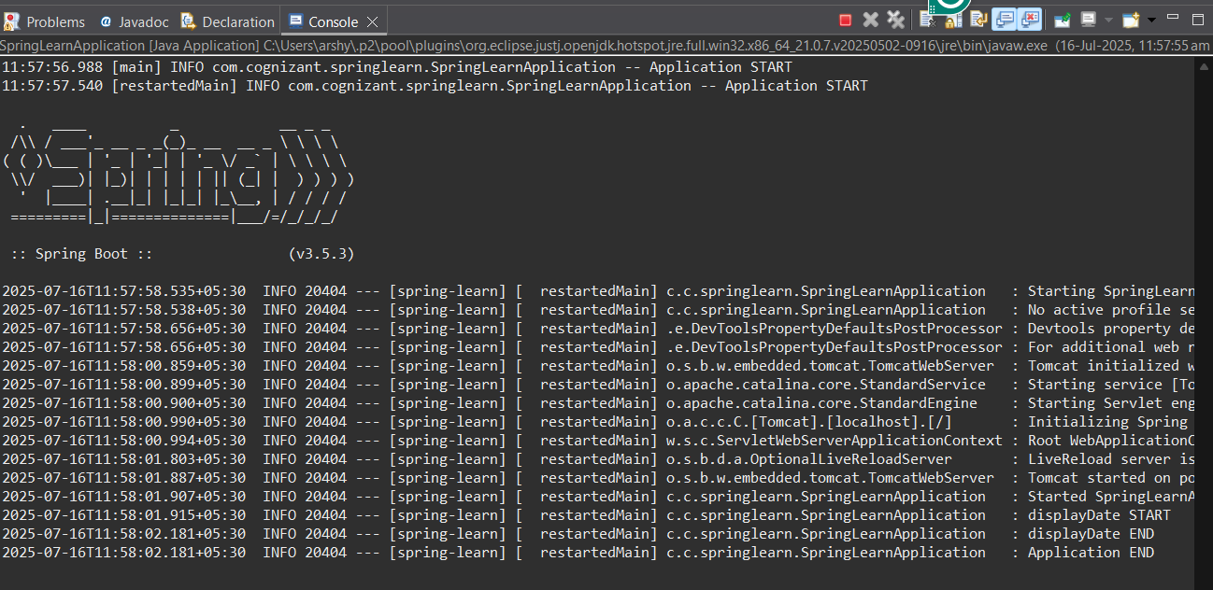

**Hands on 3**

**Spring Core - Incorporate Logging**

**Code :**

**SpringApplication.java**

package com.cognizant.springlearn;

import org.slf4j.Logger;

import org.slf4j.LoggerFactory;

import org.springframework.boot.SpringApplication;

import org.springframework.boot.autoconfigure.SpringBootApplication;

import org.springframework.context.ApplicationContext;

import org.springframework.context.support.ClassPathXmlApplicationContext;

import java.text.SimpleDateFormat;

import java.util.Date;

*@SpringBootApplication*

public class SpringLearnApplication {

LoggerFactory.*getLogger*(SpringLearnApplication.class);

public static void main(String[] args) {

***LOGGER***.info("Application START");

// Launch Spring Boot and obtain Spring-managed context

ApplicationContext springContext = SpringApplication.*run*(SpringLearnApplication.class, args);

// For demonstration, invoking the displayDate method

SpringLearnApplication app = new SpringLearnApplication();

app.displayDate();

***LOGGER***.info("Application END");

}

public void displayDate() {

***LOGGER***.info("displayDate START");

// Automatically close XML context to avoid resource leaks

try (ClassPathXmlApplicationContext context =

new ClassPathXmlApplicationContext("date-format.xml")) {

SimpleDateFormat format = context.getBean("dateFormat", SimpleDateFormat.class);

Date date = format.parse("31/12/2018");

***LOGGER***.debug("Parsed Date: {}", date);

} catch (Exception e) {

***LOGGER***.error("Date parsing error", e);

}

***LOGGER***.info("displayDate END");

}

}

**application.properties**

logging.level.org.springframework=info

logging.level.com.cognizant.springlearn=debug

logging.pattern.console=%d{yyMMdd}|%d{HH:mm:ss.SSS}|%-20.20thread|%5p|%-25.25logger**{25}**|%25M|%m%n

server port = 8081

**Output :**

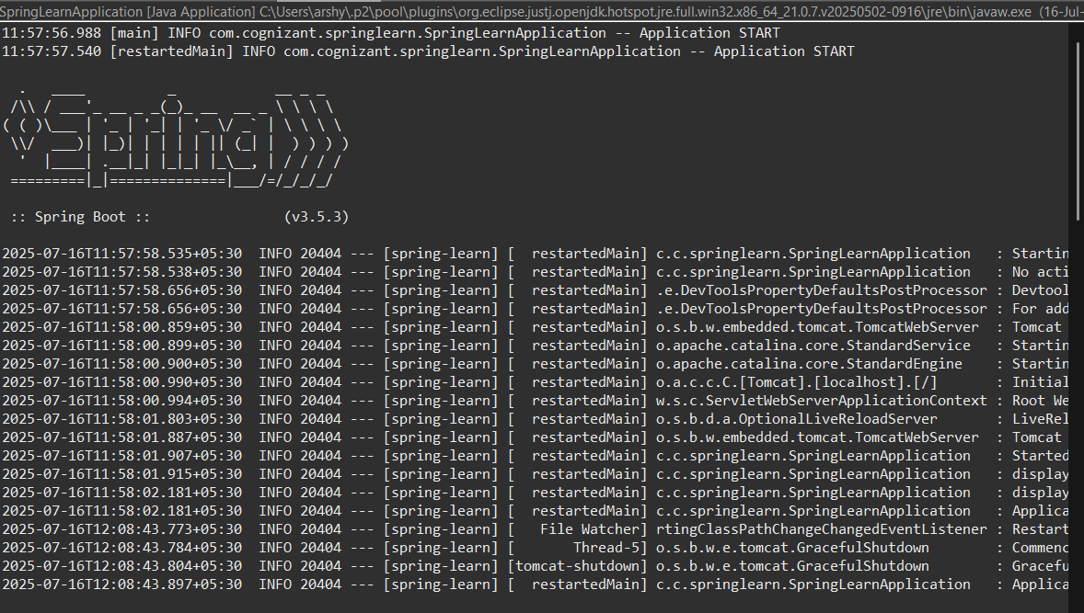

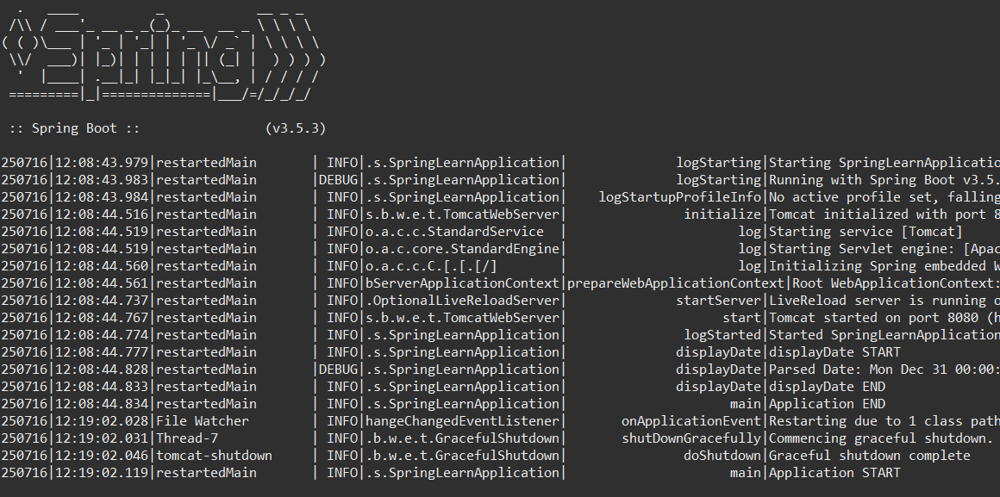

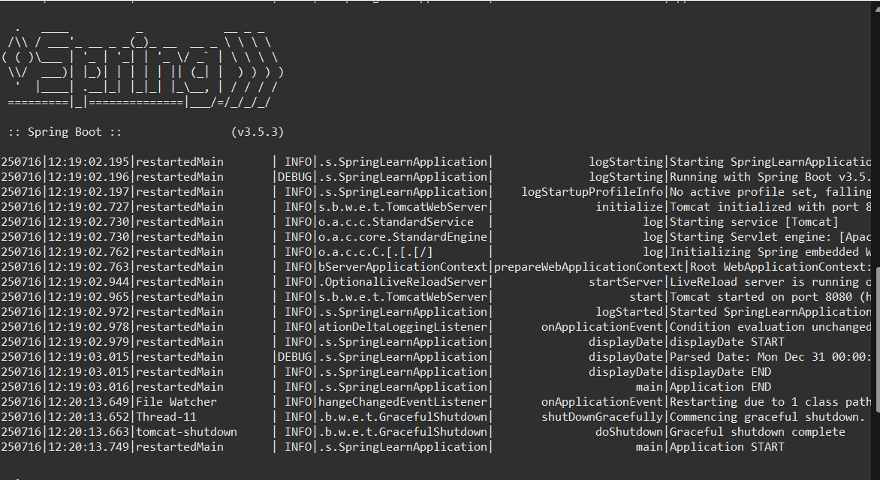

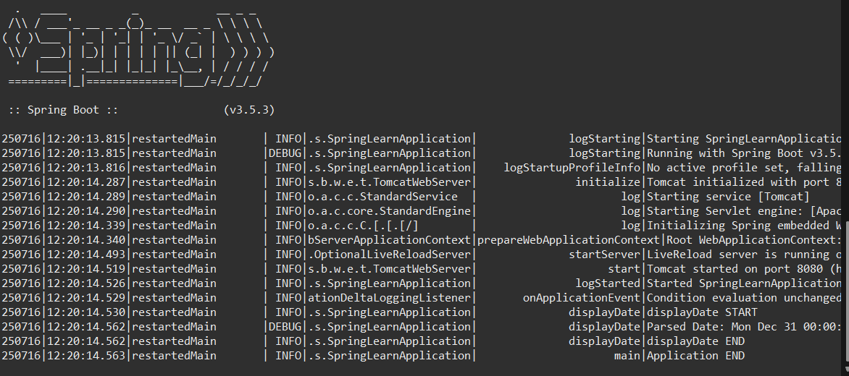

**Hands on 4**

**Spring Core – Load Country from Spring Configuration XML**

**Code :**

**SpringLearnApplication.java**

package com.cognizant.springlearn;

import org.slf4j.Logger;

import org.slf4j.LoggerFactory;

import org.springframework.boot.SpringApplication;

import org.springframework.boot.autoconfigure.SpringBootApplication;

import org.springframework.context.ApplicationContext;

import org.springframework.context.annotation.ImportResource;

*@SpringBootApplication*

*@ImportResource*("classpath:country.xml")

public class SpringLearnApplication {

private static final Logger ***LOGGER*** = LoggerFactory.*getLogger*(SpringLearnApplication.class);

public static void main(String[] args) {

***LOGGER***.info("Application START");

ApplicationContext context = SpringApplication.*run*(SpringLearnApplication.class, args);

SpringLearnApplication app = context.getBean(SpringLearnApplication.class);

app.displayDate();

app.displayCountry(context);

***LOGGER***.info("Application END");

}

public void displayDate() {

***LOGGER***.info("displayDate START");

***LOGGER***.info("displayDate END");

}

public void displayCountry(ApplicationContext context) {

***LOGGER***.info("displayCountry START");

try {

Country country = context.getBean("country", Country.class);

***LOGGER***.debug("Country : {}", country);

} catch (Exception e) {

***LOGGER***.error("Error loading country bean", e);

}

***LOGGER***.info("displayCountry END");

}

}

**Application.properties**

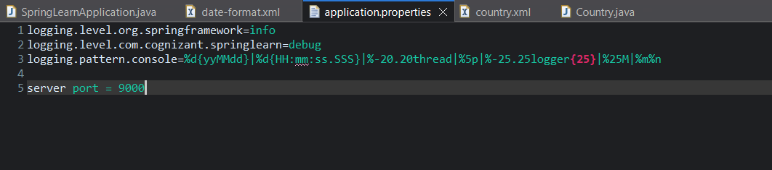

**Country.xml**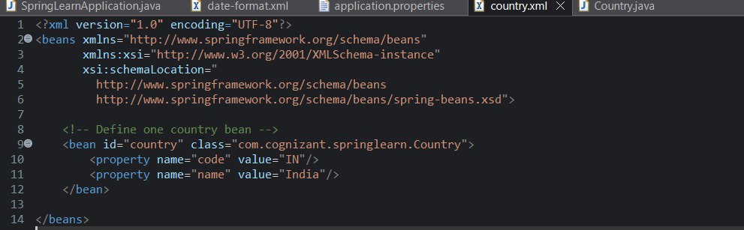

**Country.java**

package com.cognizant.springlearn;

import org.slf4j.Logger;

import org.slf4j.LoggerFactory;

public class Country {

private static final Logger *LOGGER* = LoggerFactory.*getLogger*(Country.class);

private String code;

private String name;

public Country() {

*LOGGER*.debug("Inside Country Constructor.");

}

public String getCode() {

*LOGGER*.debug("Getting code: {}", code);

return code;

}

public void setCode(String code) {

*LOGGER*.debug("Setting code: {}", code);

this.code = code;

}

public String getName() {

*LOGGER*.debug("Getting name: {}", name);

return name;

}

public void setName(String name) {

*LOGGER*.debug("Setting name: {}", name);

this.name = name;

}

*@Override*

public String toString() {

return "Country [code=" + code + ", name=" + name + "]";

}

}

**Output :**

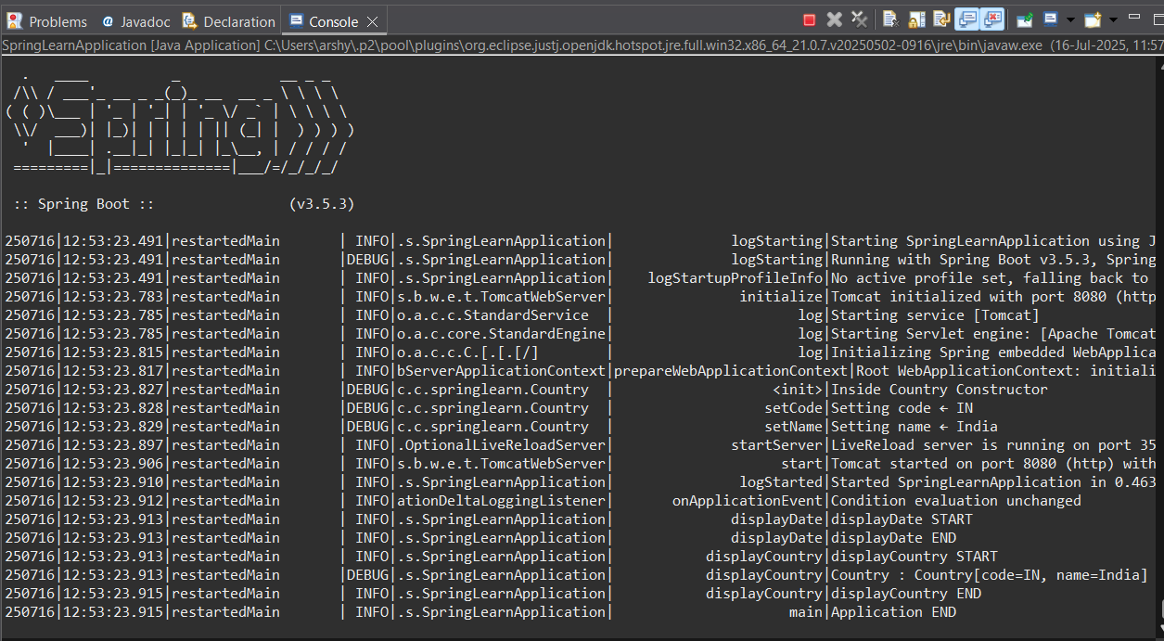

**Hands on 5**

**Spring Core – Demonstration of Singleton Scope and Prototype Scope**

**Code :**

**Springlearn.java**

package com.cognizant.springlearn;

import org.slf4j.Logger;

import org.slf4j.LoggerFactory;

import org.springframework.context.support.ClassPathXmlApplicationContext;

public class SpringLearnApplication {

private static final Logger ***LOGGER*** = LoggerFactory.*getLogger*(SpringLearnApplication.class);

public static void main(String[] args) {

SpringLearnApplication app = new SpringLearnApplication();

***LOGGER***.info("=== Testing with Singleton scope ===");

app.displayCountry();

***LOGGER***.info("=== Now testing Prototype scope (update country.xml) ===");

app.displayCountry();

}

public void displayCountry() {

***LOGGER***.info("displayCountry START");

try (ClassPathXmlApplicationContext context = new ClassPathXmlApplicationContext("country.xml")) {

Country country1 = context.getBean("country", Country.class);

Country country2 = context.getBean("country", Country.class);

***LOGGER***.debug("First country instance: {}", country1);

***LOGGER***.debug("Second country instance: {}", country2);

***LOGGER***.info("Same instance? {}", country1 == country2);

} catch (Exception e) {

***LOGGER***.error("Error loading country bean", e);

}

***LOGGER***.info("displayCountry END");

}

}

**Country.xml**

<?xml version="1.0" encoding="UTF-8"?>

<beans xmlns="http://www.springframework.org/schema/beans"

xmlns:xsi="http://www.w3.org/2001/XMLSchema-instance"

xsi:schemaLocation="

http://www.springframework.org/schema/beans

http://www.springframework.org/schema/beans/spring-beans.xsd">

<!-- Default bean: singleton scope -->

<bean id="country" class="com.cognizant.springlearn.Country"/>

</beans>

**Country.java**

package com.cognizant.springlearn;

import org.slf4j.Logger;

import org.slf4j.LoggerFactory;

public class Country {

private static final Logger ***LOGGER*** = LoggerFactory.*getLogger*(Country.class);

private String code;

private String name;

public Country() {

***LOGGER***.debug("Inside Country Constructor");

}

public String getCode() {

***LOGGER***.debug("Getting code: {}", code);

return code;

}

public void setCode(String code) {

***LOGGER***.debug("Setting code: {}", code);

this.code = code;

}

public String getName() {

***LOGGER***.debug("Getting name: {}", name);

return name;

}

public void setName(String name) {

***LOGGER***.debug("Setting name: {}", name);

this.name = name;

}

*@Override*

public String toString() {

return "Country[code=" + code + ", name=" + name + "]";

}

}

**Output :**

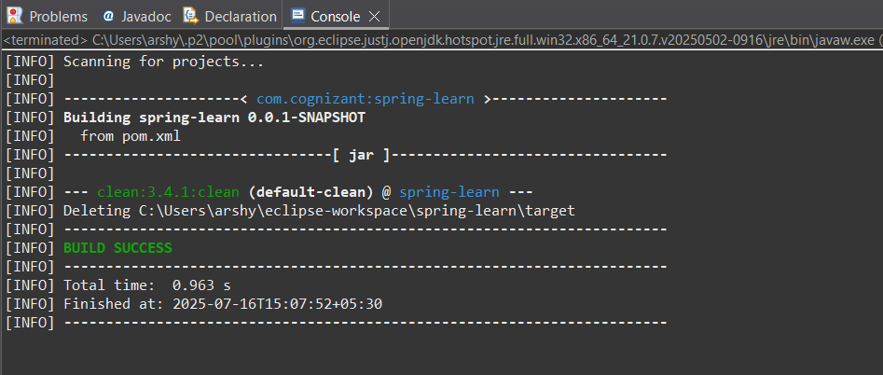

**Hands on 6**

**Spring Core – Load list of countries from Spring Configuration XML**

**Code :**

package com.cognizant.springlearn;

import org.slf4j.Logger;

import org.slf4j.LoggerFactory;

import org.springframework.context.support.ClassPathXmlApplicationContext;

import java.util.List;

public class SpringLearnApplication {

private static final Logger *log* = LoggerFactory.*getLogger*(SpringLearnApplication.class);

public static void main(String[] args) {

SpringLearnApplication app = new SpringLearnApplication();

app.displayCountries();

}

public void displayCountries() {

*log*.debug("===== Starting displayCountries() =====");

try (ClassPathXmlApplicationContext ctx = new ClassPathXmlApplicationContext("classpath:country.xml")) {

*@SuppressWarnings*("unchecked")

List<Country> countries = (List<Country>) ctx.getBean("countryList");

if (countries != null) {

countries.forEach(c ->

*log*.debug("Country: code={}, name={}", c.getCode(), c.getName())

);

} else {

*log*.debug("No countries found in countryList bean");

}

} catch (Exception e) {

*log*.error("Error occurred while loading countries: ", e);

}

*log*.debug("===== Ending displayCountries() =====");

}

}

**Server.java**

package com.cognizant.springlearn; // make sure this matches folder structure

public class Server {

public static void main(String[] args) {

System.***out***.println("Server started...");

}

}

**Output :**

